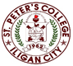

***Committed to Excellence***

St. Peter’s College

042 Sabayle St., Iligan City

**COLLEGE OF COMPUTER STUDIES (SEMINAR AND TOURS)**

**NARRATIVE REPORT ON SEMINAR (WEB-DESIGN)**

On the morning of February 24, 2024, at around 9:00 am, the 4th-year students gathered in the computer laboratory, Room A204, for a seminar by Rolijohn Clemenia. We waited for the rest of our classmates to arrive, aiming to start the seminar when everyone was present. At around 9:20 am, the seminar began with a prayer and a brief introduction of the speaker.

Sir Clemenia discussed Web Design, his main area of expertise. He shared his experiences, inspiring us to delve deeper into Web Design. He also posed various questions about real-life scenarios related to technology.

By 10:20 am, his discussion was wrapping up, and it was our turn to present our Web Design projects created in Figma. After our presentations, he provided feedback and taught us how to effectively market our websites, preparing us to be competitive in the field.

Finally, we asked Sir Clemenia questions about improving web design, best practices, routines, and more. After the Q&A session, we took pictures with him as the seminar concluded.

Prepared by:

Edward Jr A. Cabello

       Student

Checked by:

MELLANIE S. GAMBE, MSIT

Dean, College of Computer Studies

Reviewed & Approved by:

MELLANIE S. GAMBE, MSIT

Dean, College of Computer Studies

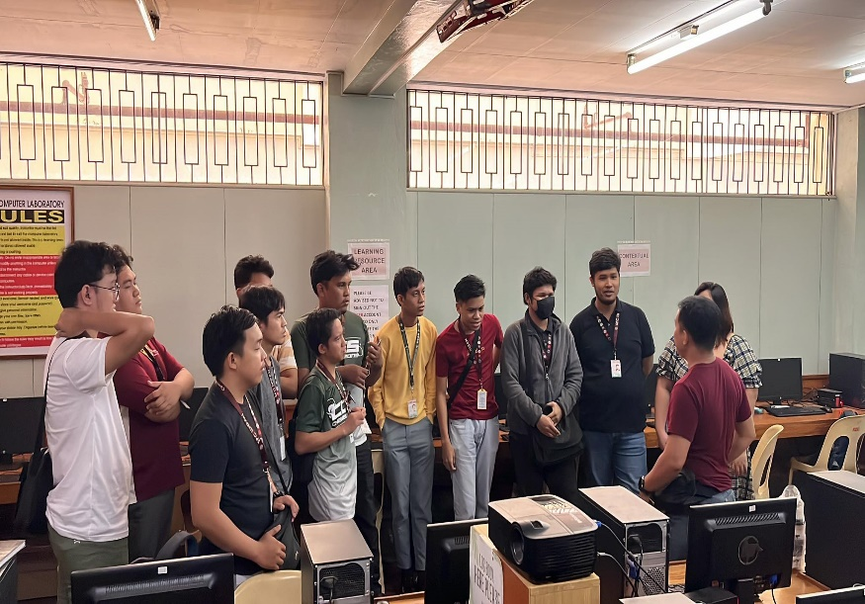

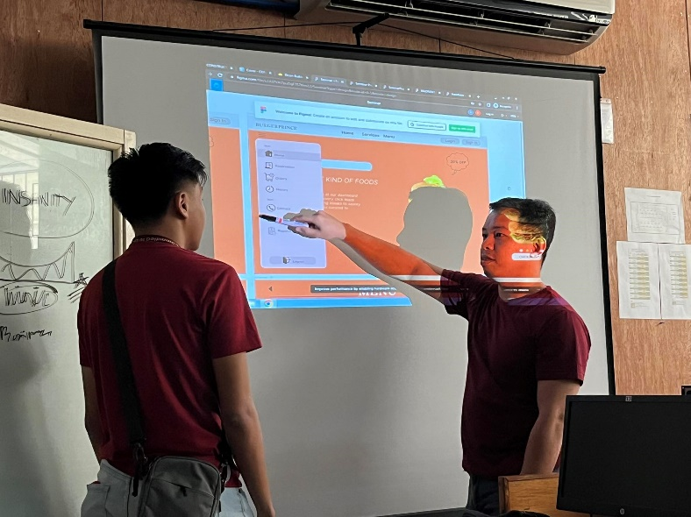

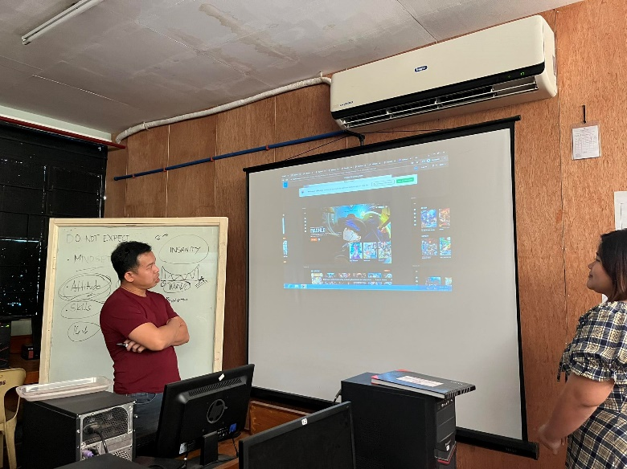

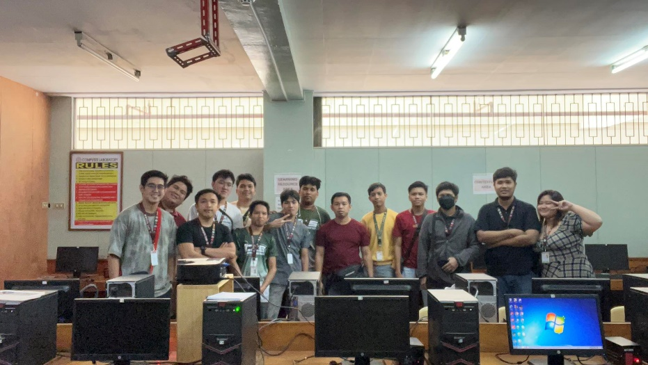

Upper-Left: Asking Questions to sir Clemenia.

Upper-Right: Explaining and Giving Feedback.

Lower-Left: Individually Expalining the web-design

Lower-Right: Giving our certificate to the speaker.